PROCUREMENT SCHEDULE AND INFORMATION.
RFP Issue Date:
Due Date for Written Questions and Clari6cations (5:00PM  CST): | April 03, 2026
Anticipated Posting of Written Responses to Questions,  Comments, and Complaints: | April 10, 2026
Deadline for Proposal Submission (5:00PM CST): | April 22, 2026 .-
Administrative Review and Evaluation Period: | April 23 – May 01, 2026
Anticipated Notice of Recommendation(s) for Award: , | May 2026 |  |  | )9k/
Anticipated Project Commencement: | June 1, 2026
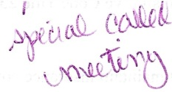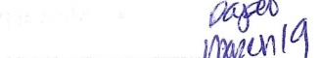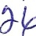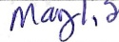
REQUEST FOR PROPOSALS
EMERGENCY MEDICAL SERVICE PROVIDER
MnENARD COUNTY HOSPITAL DISTRICT, MENARD COUNTY, TEXAS
INTRODUCTION. Menard County Hospital District (“MCHD”) is seeking Proposals Bom qualified Emergency Medical Services (EMS) providers to furnish ambulance response to medical and trauma emergencies in response to 9-1-1 calls and public safety requests 24 hours per day, 365 days per year within MCHD’s authorized service area. The selected Contractor shall provide licensed, staRed, and medically directed emergency response services consistent with all applicable federal and state laws, including but not limited to:
• Texas Health and Safety Code Chapter 773
• Texas Health and Safety Code Chapter 281
• Texas Administrative Code Title 25 Chapter 157
The selected Contractor shall deliver services in a manner that protects public health, ensures clinical excellence, and maintains compliance with all regulatory and licensing standards required by the Texas Department of State Health Services (DSHS).
MCHD SERVICE AREA. The service area is Menard MCHD, Texas, which includes 902 square miles including one incorporated city which serves as the Menard County seat (Menard, Texas). The population of MCHD from the last federal census was 1,967. The objective of this solicitation is to identify and select a provider that can deliver high-quality services in a cost-eRective manner in this rural setting with extended transportation times. Emergency calls average 25 per month over 12-month period.
Contact Person:
Janis Cordes
Board President
Menard County Hospital District
(325) 396-4515
jicordQS 1 3@gmail.com
1.
2.
3.

